# Year of the Cat

# 1.

You cant get a cat to meow, it can only do it on his own.

# 2.

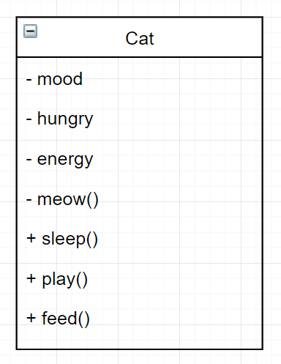

# Time in a Bottle

# 1.

